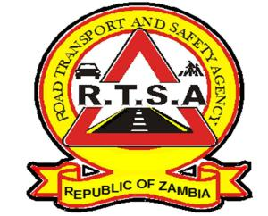

**ROAD TRANSPORT AND SAFETY AGENCY**

**PUBLIC NOTICE**

**GET ROAD TAX NOW AND WIN FREE INSURANCE COVER**

This serve to inform members of the general public that the third quarter for the year 2019 comes to an end on 30th September.

In order for the Agency to serve the public in a more efficient and effective manner, motorists and fleet owners are hereby reminded to pay for their Motor Vehicle and Trailer licences (road Tax) in advance to avoid panic buying.

The Agency, further wishes to state that there shall be no extensive after the end of the quarter. Therefore, the RTSA and Zambia Police will continue enforcing the law with regard to the validity of Road Licences.

This notice serves to inform the General Public and all Driving Licence applicants holding Temporal Driving Licences to visit the Road Transport and Safety Agency (RTSA) to have their Driving Licence cards printed.

Applicants are required to present the original copy of the Temporal Driving Licence to facilitate for the printing of the card. Clients will be issued with a Driving Licence card at no cost.

Going forward, the RTSA wishes to assure the public that modalities have been put in place to ensure that all Driving Licences cards are produced on ***“print on demand”*** basis.

Kindly take this as official notification.

Authorized for display and publication by: Date: August 2019

**The Head Public Relations**

**For/Director and Chief Executive Officer**

**Road Transport and Safety Agency**

**7th Floor, Premium House**

**Lusaka**