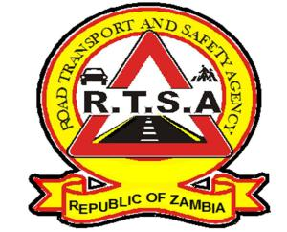

**ROAD TRANSPORT AND SAFETY AGENCY**

**PUBLIC NOTICE**

**GET ROAD TAX NOW AND WIN FREE INSURANCE COVER**

This serve to inform members of the general public that the third quarter for the year 2019 comes to an end on 30th September.

In order for the Agency to serve the public in a more efficient and effective manner, motorists and fleet owners are hereby reminded to pay for their Motor Vehicle and Trailer licences (road Tax) in advance to avoid panic buying.

The Agency, further wishes to state that there shall be no extensive after the end of the quarter. Therefore, the RTSA and Zambia Police will continue enforcing the law with regard to the validity of Road Licences.

Kindly take this as official notification. Be Road Smart, Life is Precious.

Authorized for display and publication by: Date: 6th September 2019

**The Head Public Relations**

**For/ActingDirector and Chief Executive Officer**

**Road Transport and Safety Agency**

**7th Floor, Premium House**

**Lusaka**