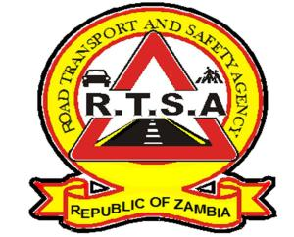 **ROAD TRANSPORT AND SAFETY AGENCY**

**RTSA WON’T EXTEND!**

The Road Transport and Safety Agency (RTS), would like to inform motorists and fleet owners that the Agency will not extend the payment of Motor Vehicle and Trailer Licenses (Road Tax) at the end of this quarter.

Motorists and fleet owners are hereby reminded to pay for Road Tax on time to avoid panic as selected RTSA offices have extended working hours from 08:00 hours to 19:00 hours from Monday to Friday and will open from 08:00 hours to 13:00 hours on Saturdays during the festive period.

The fourth quarter for the year 2019 is coming to an end on 31st December 2019. In order for the Agency to serve you in a more efficient and effective manner, motorists and fleet owners are hereby reminded to pay for their Motor Vehicle and Trailer Licences (Road Tax) for the year 2020 in advance to avoid panic.

The Road Transport and Safety Agency RTSA), wishes to start the New Year 2020 with high compliance to Statutory obligations by motorist and fleet owner for them not to be in conflict with the law.

Step up, pay your Toad tax now and let RTSA serve you with excellence.

For any queries contact the RTSA on 0211228793 or Email [**askrtsa@rtsa.org.zm**](mailto:askrtsa@rtsa.org.zm) **or visit Facebook/askrtsa.com or website:** [**www.rtsa.org.zm**](http://www.rtsa.org.zm)

**Authorised for display and publication by:** ______________________________________________________________________

**The Head- Public Relations**

**For/ Acting Director and Chief Executive Officer**

**Road Transport and Safety Agency**

**7th Floor, Premium House**

**LUSAKA**