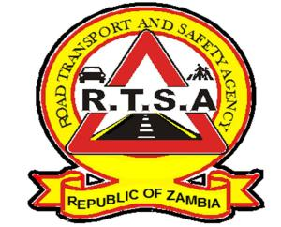

**ROAD TRANSPORT AND SAFETY AGENCY**

**PRESS STATEMENT**

**OVER 800 MOTORIST CONVICTED, FOUND GUILTY FOR VIOLATING TRAFFIC LAWS**

**LUSAKA, December 6th December 2019—** The Lusaka Fast Track Court for traffic offences has convicted 813 drivers for violating traffic rules and regulations during the month of November 2019.

As means of imposing stiffer punishment on road users disregarding traffic rules and regulations with impunity, which in most cases result into loss of life through road traffic accidents, the Road Transport and Safety Agency (RTSA), has enhanced its traffic law enforcement to ensure that most traffic offences are prosecuted through the courts of law.

In November, with accidents recorded across the country, the RTSA secured 813 convictions in the Lusaka Fast Track Court for Traffic offences involving various traffic related offences such as expired Road tax, driving a motor vehicle in a dangerous condition, plying for hire, and unlicensed driver.

Other offences were, dangerous driving, unsecured loads, contravening Statutory Instrument (SI) 76 regulation, expired certificate of fitness, use of handheld mobile phone while driving and expired/uninsured motor vehicle.

From the offences recorded and convictions secured, dangerous driving and use of mobile phones while driving remains a major challenge on the Zambian roads. Therefore, the RTSA is on high alert to bring to book all road users violating the law with impunity through its sustainable traffic law enforcement patrols countrywide in order to ensure total compliance among motorists and safeguard the safety of all road users.

In the same vain, the RTSA is seeking the cooperation of all road users and the public in general in eliminating risky behaviour that results in road injuries, fatalities and loss of property by reporting bad, careless, dangerous drivers and all traffic violations on the Toll Free Line - **983** and the WhatsApp line **0965 429499**.

**Issued by:**

**MUKELA MANGOLWA**

**PUBLIC RELATIONS MANAGER**