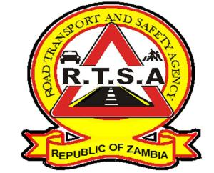 **ROAD TRANSPORT AND SAFETY AGENCY**

**STEP UP AND PAY YOUR ROAD TAX NOW!**

The fourth quarter for the year 2019 is coming to an end on 31st December 2019. In order for the Agency to serve you in a more efficient and effective manner, motorists and fleet owners are hereby reminded to pay for their Motor Vehicle and Trailer Licences (Road Tax) for the year 2020 in advance to avoid panic.

The Road Transport and Safety Agency RTSA), wishes to start the New Year 2020 with high compliance to Statutory obligations by motorist and fleet owner for the not to be in conflict with the law.

Step up, pay your road tax now and let RTSA serve you with excellence.

***RTSA – Going an extra mile, just for you.***

For any queries contact the RTSA on 0211228793 or Email [**askrtsa@rtsa.org.zm**](mailto:askrtsa@rtsa.org.zm) **or visit Facebook/askrtsa.com or website:** [**www.rtsa.org.zm**](http://www.rtsa.org.zm)

**Authorised for display and publication by:** ______________________________________________________________________

**The Head- Public Relations**

**For/ Acting Director and Chief Executive Officer**

**Road Transport and Safety Agency**

**7th Floor, Premium House**

**LUSAKA**