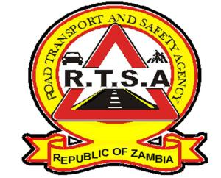

**ROAD TRANSPORT AND SAFETY AGENCY**

**PUBLIC NOTICE**

**RTSA EXTENDS ITS FOOT PRINT: OPENS SERENJE AND KAFUE SERVCE CENTERS**

In a bid to enhance its road transport, road safety and service delivery mandate, the Road Transport and Safety Agency (RTSA), has opened additional service centers in Kafue and Serenje districts respectively.

The two Stations will be open to the public on 13th December 2019. Members of the public in the respective districts are advised to obtain all RTSA services therein.

This development is aimed at enhancing the quality of services and reach of the RTSA including providing road safety education and traffic law enforcement in all parts of the country

Kindly take this as official notification.

For any queries contact the RTSA on 0211228793 or Email [**askrtsa@rtsa.org.zm**](mailto:askrtsa@rtsa.org.zm) **or visit Facebook/askrtsa.com or website:** [**www.rtsa.org.zm**](http://www.rtsa.org.zm)

Authorised for display and publication by: Date: 5th December, 2019

**The Head – Public Relations**

**For/ Acting Director and Chief Executive Officer**

**Road Transport and Safety Agency**

**7th Floor, Premium House**

**LUSAKA**