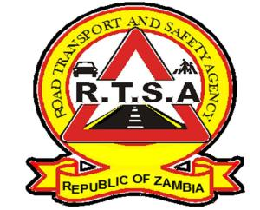

**ROAD TRANSPORT AND SAFETY AGENCY**

**PRESS STATEMENT**

**RTSA TARGETS ‘ACCIDENT FREE’ CHRISTMAS CELEBRATION**

**Warn drunk drivers of revocation of Licences**

**LUSAKA, 24th December 2019 —** The Road Transport and Safety Agency (RTSA) has set itself an ambitious task to deliver an ‘accident free Christmas festivity’ by seeking the cooperation all road users and Zambian citizens in general in eliminating risky behavior that results in road injuries, fatalities and loss of property.

Delivery his festive season road safety message to all road users, RTSA Acting Director Mr. Gladwell wished the Zambian people an ‘accident free Christmas festivity’ and cautioned motorists against lawlessness during this period and beyond.

Mr. Banda said RTSA seeks to ensure that no life will be lost on account of negligent behavior during this period and beyond.

“Therefore, the RTSA will revoke Driving Licences for all drivers found driving under the influence of alcohol. The Agency will be evoking the provisions of the Road Traffic Act No. 11 of 2002, which empowers the Office of the Director and revoke the driving Licence for any driver that seem to be a danger to the public ”, Mr. Banda said.

He has indicated that RTSA has intensified and deploy an all-out road traffic law enforcement patrols to reach out to all road users and citizens to secure their cooperation in mitigating accidents.

He adds that Agency has since deployed adequate traffic law enforcement officers on highways to curb road accidents. RTSA is carrying a joint enforcement with Zambia Police.

**Issued by:**

**FREDRICK MUBANGA**

**HEAD - PUBLIC RELATIONS**