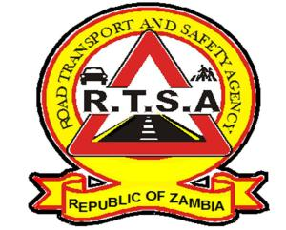

**ROAD TRANSPORT AND SAFETY AGENCY**

**PRESS STATEMENT**

**RTSA TO REVOKE LICENCES FOR PSV DRIVERS EXCEEDING SPEED LIMITS**

**LUSAKA, 28th October, 2019**- The Road Transport and Safety Agency has given seven (07) Public Service Vehicle (PSV) drivers 14 days to show cause why their Driving Licences should not be revoked for exceeding speed limits.

In separate letters dated 23rd October, 2019 addressed to the seven drivers, RTSA Acting Director and Chief Executive officer Mr. Gladwell Banda observed that the seven drivers had on several occasions opted to exceed speed limits with impunity thereby putting the lives of the travelling public in serious danger.

According to the Global Position System (GPS) installed on 88 long distance buses and monitored by the RTSA, the seven drivers were singled out to have violated speed limits on several times to an extent of driving at the ranges of 120 km/h to 145 km/h against the prescribed speed limit for PSV buses on highways which is 100 km/h, thus posing serious danger to the travelling public.

Therefore, RTSA Acting Director is evoking Section 68(1) (a) of the Road Traffic Act No. 11 of 2002 which empowers his office to revoke a Driving Licence, if in the opinion of the Director, the conduct or character of the holder is such a Licence render to be unfit to drive such a vehicle from the point of view of the safety of the public.

The seven drivers are, Lenard Musukuma, Martin Mapisa, Kelly Siame, Yuberd Simwala, Kendrick Simusikwe, Allan Chitabankana, and Morgan Sikaumba.

The Agency is of the view that PSV drivers are expected to drive with due care bearing in mind the level of responsibility they assume. Therefore, the continuous conduct to drive above the prescribed speed limits, is a serious road safety concern. The RTSA is taking a proactive approach to monitor the speed of PSV buses through GPS in bid to mitigate the risk of road traffic accidents on Zambian roads.

**Issued by:**

**FREDRICK MUBANGA**

**HEAD - PUBLIC RELATIONS**