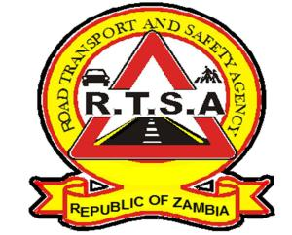

**ROAD TRANSPORT AND SAFETY AGENCY**

**PRESS STATEMENT**

**RTSA COLLECTS K900 MILLION NON-TAX REVENUE**

**LUSAKA, 24th November 2019 —** The Road Transport and Safety Agency (RTSA) has collected over K900 million in non-tax revenue in the last ten months, representing an increase of 16 per cent in collection.

Road Transport and Safety Agency (RTSA), Acting Chief Executive Officer, Mr. Gladwell Band, has disclosed that the Agency collected total revenue of K985, 962,398 from January to October 2019 against K853, 097,619 collected during the same period of 2018.

The growth in non-tax revenue collection by the RTSA could be attributed to the growth in collection to the revenue reforms government has put in place.

“RTSA is committed to being the lead Agency in the collection of non-tax revenues on behalf of government in a bid to contribute to Zambia’s social and economic growth”, Mr. Banda said.

Meanwhile, Mr. Banda stated that the Agency is transforming towards delivering a safer, inclusive and economically enabling road transport system.

Mr. Banda disclosed that the RTSA has put in place various strategies to enhance and strengthen its road transport, safety and service delivery manage to reach out to all road users.

The Mr.Banda has stated that the RTSA would be opening three new Service Centres in Serenje, Petauke, and Kafue districts before the end of 2019 to enhance its footprint.

**Issued by:**

**FREDRICK MUBANGA  
HEAD - RELATIONS MANAGER**