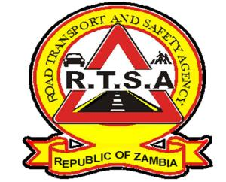

**ROAD TRANSPORT AND SAFETY AGENCY**

**PUBLIC NOTICE**

**RTSA EXTENDS WORKING HOURS IN SELECTED SERVICE CENTRES THIS FESTIVE SEASON**

Effective Monday, 9th December 2019, selected road transport and safety service centers will extend operating hours to facilitate for the payment of Road Tax.

Therefore, the following service centers will open from 08:00 hours to 19: 00 hours from Monday to Friday;

* Lumumba, Premium House, Ridgeway, Cosmopolitan Mall, Kabwe, Ndola Main, Luanshya, Kitwe Main, Copperhill, Chingola, Mufurila, Solwezi, Mansa, Kasama, Mpika, Chipata, Mongu, Mazabuka, Monze, Choma, and Livingstone Main

Further, all RTSA Stations will also be open to the public during lunch time. Additionally, all RTSA service centers across the country will be open to the public on Saturdays from 08:00 hours to 13:00 hours.

Motorists, fleet owners and members of the general public are implored to utilize this period to pay for Road Tax and other Statutory obligations in relations to road transport.

Kindly take this as official notification.

For any queries contact the RTSA on 0211228793 or Email [**askrtsa@rtsa.org.zm**](mailto:askrtsa@rtsa.org.zm) **or visit Facebook/askrtsa.com or website:** [**www.rtsa.org.zm**](http://www.rtsa.org.zm)

Authorised for display and publication by: Date: 5th December, 2019

**The Head – Public Relations**

**For/ Acting Director and Chief Executive Officer**

**Road Transport and Safety Agency**

**7th Floor, Premium House**

**LUSAKA**