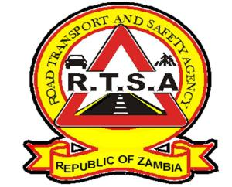

**ROAD TRANSPORT AND SAFETY AGENCY**

**PUBLIC NOTICE**

**SUSPENSION OF ONLINE PAYMENT FOR SPEED FINES**

On 20th February 2019, the Road Transport and Safety Agency suspended all online platforms for settlement of speed fines under the Road Safety Law Enforcement .The Agency therefore, wishes to remind all motorist that all online platforms for settlement of speed fines remain suspended until further notice and the public are urged not to pay speed fines using any online payment platforms.

From the foregoing, all motorist with unpaid speed fine are advised to utilize any of the listed banks below for payment over the counter using the 16-digit contained in the notification sent via SMS.

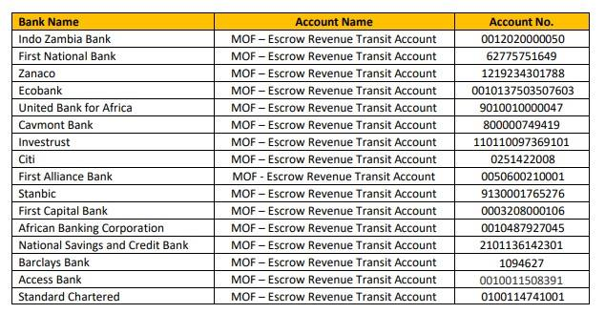

Kindly take this as official notification.

For any queries contact the RTSA on 0211228793 or Email [**askrtsa@rtsa.org.zm**](mailto:askrtsa@rtsa.org.zm) **or visit Facebook/askrtsa.com or website:** [**www.rtsa.org.zm**](http://www.rtsa.org.zm)

Authorised for display and publication by: Date: 1st December, 2019

**The Head – Public Relations**

**For/ Acting Director and Chief Executive Officer**

**Road Transport and Safety Agency**

**7th Floor, Premium House**

**LUSAKA**