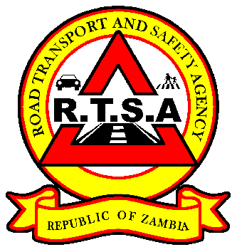

**ROAD TRANSPORT AND SAFETY AGENCY**

**PRESS STATEMENT**

**RTSA CAUTIONS DRIVERS TO BE CAUTIOUS ON THE ROAD TO AVOID ACCIDENTS**

***…As 12 die in Ndola bus accident***

**LUSAKA, 6th March 2020** - The Road Transport and Safety Agency (RTSA), wishes to convey heartfelt condolences to the families of the people that died in the road traffic accident along the Ndola – Kapiri Mposhi road in the early hours of today.

Eleven (11) people died on the spot while one died in hospital following a fatal road accident which happened around 05:00 hours this morning involving a Rosa Bus registration number ADE 2843 and a Volvo truck registration number BAJ 1795.

Preliminary accident investigations conducted by the RTSA have revealed that the driver of the Volvo truck belonging to South Gate Transport failed to stop as the road had an obstruction which was well marked and secured with warning signs following a broken down truck belonging to Shaan Carriers but instead decided to cut-in to the opposite lane thereby, colliding head-on with the Rosa Bus.

Further, the investigations have revealed that both drivers failed to apply defensive driving skills to avoid the accident but opted not to stop even after flashing lights warning each other of a possible collision.

The RTSA is concerned with the conduct of drivers which has resulted in the loss of lives which could have been avoided.

RTSA Director and Chief Executive Officer Mr. Gladwell Banda is of the view that the drivers acted negligently, violated the driver’s duty of reasonable care and demonstrated to be a danger to the public. From the foregoing, the RTSA has written to the driver of the Volvo truck Mr. Silas Munenga who is currently in police custody to show cause within seven (07) days as to why his Driving License should not be revoked in line with section 68 of the Road Traffic Act No.11 of 2002.

**Issued by:**

**FREDRICK MUBANGA**

**HEAD - PUBLIC RELATIONS**