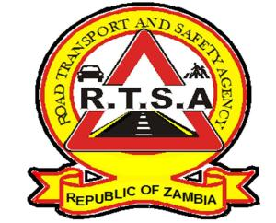

**ROAD TRANSPORT AND SAFETY AGENCY**

**PUBLIC NOTICE**

**CLOSURE OF SELECTED RTSA OFFICES TO FACILITATE FOR DISINFECTION**

In light of the developing situation with regard to COVID-19, the Road Transport and Safety Agency (RTSA) wishes to advise its clients and the general public that the following RTSA offices will be closed to the public today Monday 10th August, 2020 from 14:00 to 17:00 hours to facilitate for disinfection of the premises:

**a. Head Office situated at Premium House on the 7th and 8th floor;**

**b. Premium House Service Centre; and**

**c. Dedan Kimathi Service Centre.**

For any queries contact the RTSA on 0211228798 or Email [**askrtsa@rtsa.org.zm**](mailto:askrtsa@rtsa.org.zm) **or visit Facebook/askrtsa.com or website:** [**www.rtsa.org.zm**](http://www.rtsa.org.zm)

Authorised for display and publication by: Date: 10th August 2020

**The Head – Public Relations**

**For/ Director and Chief Executive Officer**

**Road Transport and Safety Agency**

**7th Floor, Premium House**

**LUSAKA.**