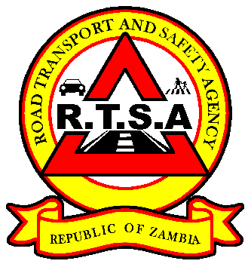

**ROAD TRANSPORT AND SAFETY AGENCY**

**PRESS STATEMENT**

**SIX PEOPLE DIE IN A FATAL ACCIDENT**

**LUSAKA, 28th September 2020**- Six people have died in a fatal road accident in Mwense District along the Mwense-Mansa road in Luapula Province.

The accident happened around 07:00 hours today, after the driver of a Zhong Tong Bus registration number AIB3978 belonging to VIDA Logistics Transport driven by Kedrick Simusokwe, was avoiding hitting into a pothole and in the process killed Winstone Kalemfu, who was riding a motor bike and coming from the opposite direction and lost control before overturning.

Accident investigations by the Road Transport and Safety Agency (RTSA) indicate that due to the impact, Kalemfu and five other passengers died on the spot, while 14 others including the driver sustained serious injuries and 19 had minor injuries.

The Bus had a shattered windscreen, depressed roof while the motor bike was extensively damaged.

The Road Transport and Safety Agency (RTSA), would like to caution motorists, particularly Public Service Vehicle (PSV) drivers to observe speed limits and obey traffic regulations and laws.

The RTSA is monitoring driver behaviour of all PSV drivers and those found wanting risk having their licenses revoked as provided for in the Road Traffic Act No.11 of 2002.

**Issued by:**

**FREDRICK MUBANGA**

**HEAD - PUBLIC RELATIONS**