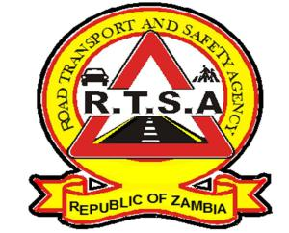

**ROAD TRANSPORT AND SAFETY AGENCY**

**PUBLIC NOTICE**

**ELECTRONIC PAYMENT FOR COMMERCIAL TRANSPORTERS**

The Ministry of Finance has granted the Road Transport and Safety Agency (RTSA), authority to extend the usage of an electronic payment solution for First Capital Bank and ECO Bank using the Inter Africa payment system.

In this regard, all commercial transporters are urged to register on the electronic payment platform with no extra cost for an alternative option of paying electronically for RTSA services at port of entry.

The Agency is committed to supporting government efforts in combating the fight against transmission of the COVID-19 pandemic while continuing with service delivery. Therefore, the electronic payment system will reduce cash handling and physical interaction during this period.

For any queries contact the RTSA on 0211228798 or Email [**askrtsa@rtsa.org.zm**](mailto:askrtsa@rtsa.org.zm) **or visit Facebook/askrtsa.com or website:** [**www.rtsa.org.zm**](http://www.rtsa.org.zm)

Authorised for display and publication by: Date: 16th September, 2020

**The Head – Public Relations**

**For/ Director and Chief Executive Officer**

**Road Transport and Safety Agency**

**7th Floor, Premium House**

**LUSAKA**