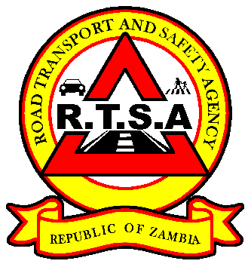**PRESS STATEMENT**

ERB-Logo

**RTSA, ERB TO ENSURE STEADY, STABLE TRANSPORTATION OF FUEL ACROSS THE COUNTRY**

**LUSAKA, 23rd October 2020** - The Road Transport and Safety Agency (RTSA) in consultation with the Energy Regulation Board (ERB) have sanctioned Road Fuel tankers to transport fuel beyond the restricted period of 18:00 hours to 06:00 hours to ensure the steady and stable supply of fuel across the country.

Therefore, there will be no enforcement of Statutory Instrument No. 76 of 2016 which restricts the movement of Public Service Vehicles at night for all trucks transporting fuel. This measure is in addition to the waiver of clause 6.2.2 (g) in the Zambian Standard **ZS 372: Transportation of Petroleum Products and Operational Requirements for Road Tank Vehicles – Code of Practice**, which prohibits the movement of fuel road tankers carrying petroleum products between 18:00 hours and 06:00 hours. The waiver will remain in force until the distribution of fuel to all parts of the country is stable.

Traffic law enforcement officers are therefore advised to ensure the smooth flow of traffic and accord express clearance to fuel tankers to facilitate prompt delivery of fuel in the country. However, road fuel tanker drivers are cautioned to follow all traffic rules and regulations to avoid road traffic accidents in the process.

As has been stated before, the disruption of the normal supply of fuel was due to the strike action by truck drivers, which also affected fuel tanker drivers. However, fuel tankers have since resumed normal operations countrywide and all measures have been put in place to ensure safe passage and delivery of petroleum products to retail sites countrywide.

The waiver to allow fuel tankers unrestricted movement is in the public interest to avoid disruption to economic and social activities. In the event of any incidents or the need for clarifications stakeholders may call the RTSA Toll Free line **983** or the ERB Toll Free Line **8484**.

**Jointly issued by:**

**Fredrick Mubanga Kwali Mfuni**

**HEAD-PUBLIC RELATIONS – RTSA MANAGER PUBLIC RELATIONS –ERB**