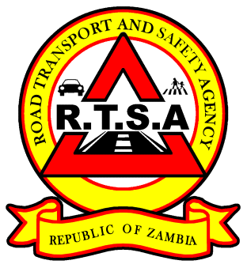

**ROAD TRANSPORT AND SAFETY AGENCY**

**PRESS STATEMENT**

**RTSA refutes false Public Notice on Drivers Licences**

The Road Transport and Safety Agency (RTSA) would like to refute a Public Notice circulating on social media regarding requirements for obtaining a Driver’s Licence purporting to have been issued by the Agency.

The Agency would therefore like to advise members of the public to ignore this misinformation as it was not generated or authorised by the RTSA.

Members of the public are further informed that requirements for acquiring a Driver’s Licence remain unchanged and does not include an applicant’s academic qualifications.

In the same vein, the Agency would like to strongly warn perpetrators of this misinformation that that the RTSA will engage relevant authorities and trace the people involved and bring them to book.

For any clarification, please call the Public Relations Department on 0211237003 or the RTSA Call Centre on 0955 983983.

Issued by:

Mukela Mangolwa

A / Head Public Relations