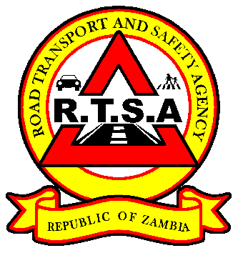

**ROAD TRANSPORT AND SAFETY AGENCY**

**PRESS STATEMENT**

**PSV OPERATORS URGED TO ADHERE TO MoH COVID-19 PUBLIC HEALTH GUIDELINES**

**LUSAKA, 05th January 2021** - The second wave of the COVID – 19 pandemic poses a great challenge for Zambia’s public transport system.

Road Transport and safety Agency Director and Chief Executive Officer Mr. Gladwell Banda has said the Agency has heightened the application of public health measure regarding public transportation.

“Mass public transportation vehicles such as buses have been identified as hotspots for the rapid spread of the COVID – 19 virus. The traveling public is therefore, advised to always put on face masks when using public transport. The proper use of masks can significantly reduce the probability of contagion” Mr. Banda said.

Mr. Banda has stated that the RTSA in collaboration with the Zambia police will ensure total compliance to mandatory use of face masks in public transportation.

To this effect, bus drivers, bus conducts and all passenger Public Service Vehicle (PSV) operators have been guided not to allow any person on a bus or taxi without a face mask.

Further, all PSV operators are guided to provide facilities for regular hand washing or sanitizing at all bus stations.

The RTSA with guidance from the Ministry of Transport and Ministry of Health will continue working on modalities to provide alternative strategies and measures to mitigate the spread of COVID-19 pandemic in public transportation.

**Issued by:**

**Fredrick Mubanga**

**Head-Public Relations**

e COVID-19 pandemic poses a great challenge for contemporary public transportation worldwide, resulting

from an unprecedented decline in demand and revenu

e COVID-19 pandemic poses a great challenge for contemporary public transportation worldwide, resulting

from an unprecedented decline in demand and revenu