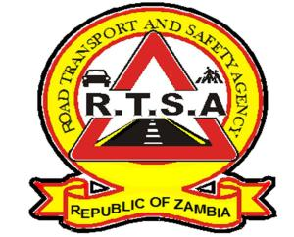

**ROAD TRANSPORT AND SAFETY AGENCY**

**PRESS STATEMENT**

**RTSA IMPOUND TRUCK FOR CARRYING OVER 60 UNAUTHORISED PASSENGERS**

**LUSAKA - 3rd March 2021** - The Road Transport and Safety Agency (RTSA) has impounded a Kalomo-bound truck for the offence of plying for hire and reward against Section 102 of the Road Traffic Act Number 11 of 2002.

According to the Road Traffic Act No. 11 of 2002; "No person shall use or cause or permit to be used any motor vehicle for the purpose of standing or plying for hire or as a public service vehicle for the carriage of persons unless there is in force in relation to the vehicle, a road licence authorising such use,"

This came in the wake of an operation by RTSA on the Great North Road where a Hino truck with registration number AEB 1644 from Kasumbalesa driven by Kelvin Mweemba was intercepted at Ten Miles with over 63 passengers on board.

The Agency has also charged the driver for exceeding the limit of the number of occupants of a motor vehicle contrary to Section 166 of the Road Traffic Act Number 11 of 2002.

The Road Traffic Act No. 11 of 2020 states that; "No person shall use or cause or permit to be used on a road any motor vehicle in which the number of occupants, including the driver, exceeds the seating capacity of such a motor vehicle as determined in such a manner and by such method as may be prescribed.

The conduct of the driver is detrimental to road safety as it poses a great risk to the safety of the passengers.

Trucks are not designed to carry passengers as they do not have sufficient safety features such as seat belts.

The Agency has warned of stern action against any public transporter found abrogating traffic rules and regulations with impunity.

**Issued by:**

**FREDRICK MUBANGA**

**HEAD - PUBLIC RELATIONS**