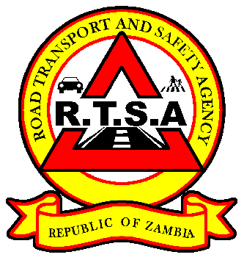

**ROAD TRANSPORT AND SAFETY AGENCY**

**PRESS STATEMENT**

**RTSA COMMENDS PSV DRIVER FOR SAVING LIVES OF 23 PASSENGERS**

**LUSAKA, 17th February 2021** - The Road Transport and Safety Agency (RTSA) has commended a Public Service Vehicle (PSV) driver, Deus Mwenya for executing defensive driving skills thereby saving the lives of 23 passengers.

On 12th February 2021, a Marcopolo Scania Irizar Bus belonging to Kondwani Bus Services with registration number ALR 2990 was involved in a road traffic crash along the Mongu - Senenga Road in Western Province after the driver of the bus hit into fourteen (14) cows and twelve (12) died on the spot.

“The probable cause of the crash was attributed to non-adherence of rule No. 61 of the Zambian Highway Code, on the part of the cattle handlers. There was no one to warn the driver on the crossing of the animals on the road as the animals were crossing the road just before the descent and could not be noticed at a reasonable distance by the driver of the Bus. Further, Section 209 (1) provides that, subject to the provisions of subsection (2), no person shall leave or permit any animal to be on any road and no person shall leave any such animal in a place from which it may stray on to such road,” The accident investigation report indicates.

And in a letter of commendation to the driver, RTSA Director and Chief Executive Officer Mr. Gladwell Banda stated that the driver’s decision to save the lives of the twenty-three (23) passengers on the bus was recommendable.

“The driver was faced with a very difficult situation, and in the Agency’s considered opinion, he made the right choice. While the loss of the animals is regrettable, we believe that human life is more important and should be protected at all costs,” Mr. Banda said.

Mr. Banda said the RTSA will heighten messaging and publicity targeting communities in rural highways on the need to secure animals when crossing the road to avoid such road traffic crashes in future.

And the Agency has directed Khondwani Bus Services to activate the Global Position System (GPS) on the bus in line with Statutory Instrument No.78 of 2016 as the GPS was deactivated at the time of the accident.

Meanwhile, the RTSA as has warned and caution Straight Lines Investment against the revocation of the Road Service Licence (RSL) following a road traffic accident on 19th January 2021 along the Kitwe-Chingola road, Chambishi area on the Copperbelt Province involving three motor vehicles - a Tipper rigid truck registration number AGB 7213 ZM, a Mitsubishi Canter light truck registration ALE 9368 and a Public Service Vehicle (PSV) bus registration number AOB 3101 in which one (1) person died and 21 sustained injuries.

The Agency has since engaged the operator to assist the company in developing a fleet management police in a bid to improve its road safety profile.

**Issued by:**

**Fredrick Mubanga**

**Head-Public Relations**