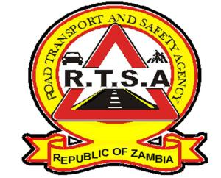 **ROAD TRANSPORT AND SAFETY AGENCY** **PUBLIC NOTICE**

**SWINDLING OF UNSUSPECTING MEMBERS OF THE PUBLIC**

The Road Transport and Safety Agency (RTSA) would like to caution members of the general public against some unscrupulous people maliciously purporting to be RTSA staff and soliciting payment on the pretext of offering various Agency services.

The Agency has received numerous reports that unknown persons have continuously swindled unsuspecting RTSA clientele and other members of public by masquerading as Agency employees and soliciting for money in the process. The unknown fraudsters have been contacting drivers and other members of the public using some known mobile phone numbers and claiming the following:

* That the particular member of public (victim) has a traffic infringement and thus their motor vehicle or driving license would be blocked on the RTSA system if they didn’t send some money mostly via mobile money platforms;
* That their driving license has anomalies on the RTSA system and thus they would be blocked if not resolved. In the process they (fraudsters) solicit for money from them as an inducement for resolving their issues;
* That the Agency is running a data migration exercise for driving licenses and motor vehicle registration books and as such all RTSA clientele would have to migrate to the new system as soon as possible; and
* That the Agency was employing and thus they (victims) should send a certain amount of money for medicals so that they may be considered for employment.

The Agency is hereby dispelling these assertions and strongly condemns these acts. In view of the above, kindly take note that the Agency has reported the matter to the Zambia Police Service and Zambia Information and Telecommunications Authority (ZICTA) for investigations.

Members of the public are therefore advised to seek RTSA services from Agency stations and authorized outsourced institutions. Impersonation and extortion is an offence contrary to Section 18(a) of the Anti-Corruption Act no. 3 of 2012 and section 296 of the Penal code respectively. And those found wanting will be prosecuted according to the provisions of the law.

Kindly report suspicious requests to the Zambia Police and RTSA on ***0211228798.***

Authorised for display and publication by: 15th March 2021

**The Head – Public Relations**

**For/Director and Chief Executive Officer**

**Road Transport and Safety Agency**

**7th Floor, Premium House**

**LUSAKA**