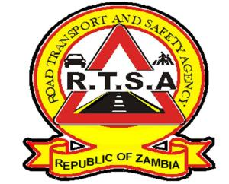

**ROAD TRANSPORT AND SAFETY AGENCY**

**PRESS STATEMENT**

**RTSA TO REVOKE LICENCES FOR PSV DRIVERS EXCEEDING SPEED LIMITS**

**LUSAKA, 19th October, 2021**–The Road Transport and Safety Agency (RTSA) has expressed concern over the continued disregard to speed limits by Public Service Vehicle (PSV) drivers.

The Agency will in the course of this week write to all PSV drivers in question, to show cause why their driving licenses should not be revoked for exceeding speed limits with impunity thereby, putting the lives of the travelling public in serious danger.

According to the Global Position System (GPS) installed on over 500 long distance buses and monitored by the RTSA, records indicate an increase in drivers violating speed limits on several occasions to an extent of driving at the ranges of 120 km/h to 200 km/h against the prescribed speed limit for PSV buses on highways which is 100 km/h, thus posing serious danger to the travelling public.

Therefore, the Agency will be exercising section 68(1) (a) of the Road Traffic Act No. 11 of 2002 which empowers the RTSA to revoke a driving licence, if in the opinion of the Director, the conduct or character of the holder of such a licence is rendered to be unfit to drive such a vehicle from the point of view of the safety of the public.

The Agency is of the view that PSV drivers are expected to drive with due care bearing in mind the level of responsibility they assume.

Therefore, the continuous disregard to traffic rules and regulations by PSV drivers, is a serious road safety concern.

The RTSA is taking a proactive approach to monitor the speed of PSV buses through GPS in bid to mitigate the risk of road traffic crashes on Zambian roads.

**Issued by:**

**FREDRICK MUBANGA HEAD - PUBLIC RELATIONS**