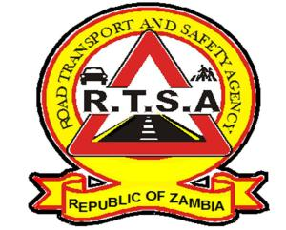

**ROAD TRANSPORT AND SAFETY AGENCY**

**PUBLIC NOTICE**

**PRINTING OF ROAD TAX ON BOND PAPER**

The Road Transport and Safety Agency (RTSA) in collaboration with the Ministry of Finance and Smart Zambia recently unveiled the RTSA online payment solution under an integrated system called the Government Service Bus (GSB) and payment Gateway System.

The online services portal presents various opportunities for the Agency in terms of effective service delivery and increase in the compliance levels for payment of statutory fees such as road tax.

The online payment solution allows customers to make cashless payments for services through the web-based online portal, mobile payments, debit cards, vendor terminals, e-kiosks, electronic points of sale, and electronic bank transfers.

In this regard, motorists are able to pay for services such as road tax online and print out the road tax token on bond paper which they are required to display on the motor vehicle and will not be compelled to get a print out from RTSA service centres.

Therefore, no motorists should be made to pay any fee to either RTSA or Zambia Police Service officers for displaying road tax printed on bond paper. Printing of road tax on bond paper is legal and authorised by the Agency.

For any queries contact the RTSA on 0211228798 or Email [**askrtsa@rtsa.org.zm**](mailto:askrtsa@rtsa.org.zm) **or visit Facebook/askrtsa.com or website:** [**www.rtsa.org.zm**](http://www.rtsa.org.zm)

Authorised for display and publication by: Date: 22nd March, 2023

**The Ag. Head – Public Relations**

**For/ Director and Chief Executive Officer**

**Road Transport and Safety Agency**

**Road Safety House**

**Dedan Kimathi Road**

**LUSAKA**