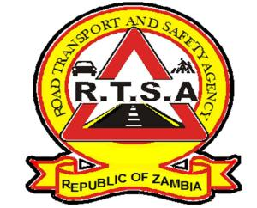

**ROAD TRANSPORT AND SAFETY AGENCY**

**NOTICE TO THE PUBLIC**

**DE-REGISTRATION OF INACTIVE VEHICLES**

This notice serves to inform the General Public that the Road Transport and Safety Agency (RTSA) will in accordance with Section 25(3) of the Road Traffic Act No. 11 of 2002 carry out a motor vehicle and trailer de-registration exercise of all motor vehicles and trailers that have not been licensed (road tax) or exempted from being licensed, for a consecutive period of five (5) years. Registration marks for vehicles and trailers that will be de-registered will accordingly be re-assigned to other motor vehicles and trailers.

De-registration is a process of removing a motor vehicle or trailer from the National Motor Vehicle Register (NMVR) due to the following reasons:

1. If the vehicle becomes inactive for a period of more than five (5) years;
2. Export purposes; and
3. Scrap.

The motor vehicle and trailer de-registration exercise is intended to remove inactive vehicles from the NMVR.

The effective date for the de-registration exercise is 1st August, 2023.

For more information, contact the RTSA on 0211228798 or Email [**askrtsa@rtsa.org.zm**](mailto:askrtsa@rtsa.org.zm) **or visit Facebook/askrtsa.com or website:** [**www.rtsa.org.zm**](http://www.rtsa.org.zm)

*Authorised for display and publication by: Date:21stJune, 2023*

**The Ag. Head – Public Relations**

**For/ Director and Chief Executive Officer**

**Road Transport and Safety Agency**

**Road Safety House**

**Dedan Kimathi Road**

**LUSAKA**