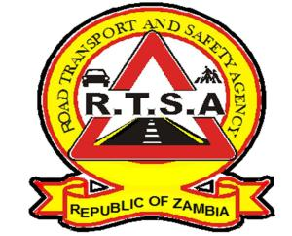

**ROAD TRANSPORT AND SAFETY AGENCY**

**PUBLIC NOTICE**

**ISSUANCE OF DRIVER'S LICENCE CARDS**

The Road Transport and Safety Agency (RTSA), would like to inform members of the public that the Agency is not printing driver’s Licence Cards at some of the RTSA customer service centres.

The RTSA service centres will be issuing Temporary Drivers Licences (TDL) as provided for in the Statutory Instrument (SI) No. 50 of 2020, The Road Traffic (Driving Licence) Regulations. This will be for a period of twenty-one (21) days within which the Agency expects the printing of cards to normalise.

Members of the public and applicants will be informed when the issuance of cards normalises.

The RTSA regrets the inconvenience this may cause.

For any queries contact the RTSA on 0211228793 or Email [askrtsa@rtsa.org.zm](mailto:askrtsa@rtsa.org.zm) or visit Facebook/askrtsa.com or website: [www.rtsa.org.zm](http://www.rtsa.org.zm)

Authorised for display and publication by: 22nd June 2023

Mukela Mangolwa Acting. Head - Public Relations Department

For/Director and CEO

Road Transport and Safety Agency

Road Safety House

Dedani Kimathi Road

**LUSAKA**