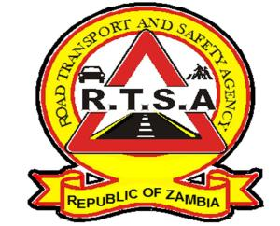

**ROAD TRANSPORT AND SAFETY AGENCY**

**PRESS STATEMENT**

**RTSA IMPOUNDS 322 IN ‘OPERATION CBD CLEAN-UP’**

**LUSAKA, 26th July 2023** – The Road Transport and Safety Agency (RTSA) has in the last 7 days charged 322 people in Lusaka for the offence of Plying for hire and reward and the offence of obstruction of roadway.

Out of the 322, 120 include 19 branded online hailing taxi drivers, 100 private motor vehicle drivers and a motorbike rider who were impounded for the offence of plying for hire and reward contrary to section 100(1) of the Road Traffic Act No. 11 of 2002.

Out of the 120 impounded and charged, 49 motorists have so far been convicted through the Lusaka Fast Track Court while the rest of the impounded motor vehicles have been parked at the RTSA Impound Yard in MIMOSA pending prosecution.

The Agency has also charged and impounded 202 Public Service Vehicles (PSVs) for obstruction of roadway, out of which 58 have also been prosecuted and convicted by the Lusaka Fast Track court.

The RTSA would also like to caution motorists to avoid parking their vehicles on road islands, undesignated spots and offloading or loading cargo on roadways as this is an offence and the Agency has also started enforcing the law in this regard.

The RTSA is committed to ensuring that sanity is maintained in the Lusaka CBD and across the country in relation to public transport and the behaviour of all motorists. The Agency, therefore intends to sustain this operation for as long as it takes to bring sanity back to our roads.

Authorised for display and publication by: Date: 26th July 2023

**Mukela Mangolwa**

**Acting Head - Public Relations  
For/ Director and Chief Executive Officer  
Road Safety House**

**Dedan Kimathi Road  
LUSAKA**