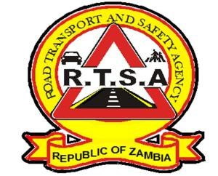

ROAD TRANSPORT AND SAFETY AGENCY

PRESS STATEMENT

THE RTSA SECURES 1,030 CONVICTIONS IN THE MONTH OF JULY 2023 IN THE LUSAKA FAST TRUCK COURT.
LUSAKA, 15th August 2023 — The Road Transport and Safety Agency (RTSA) has secured 1,030 convictions in the Lusaka Fast Track Court on Traffic offences in the month of July this year.
The highest convictions in July were expired road tax with 296 convictions, expired Identity with 109 convictions, expired Certificate of Fitness with 86 convictions, expired Test Certificate with 69 convictions and dangerous driving with 63 convictions.
Other offences that resulted in convictions were alighting, obstruction of roadway by motor vehicle, plying for hire and reward, unlicensed driving, expired Insurance on a motor vehicle, unlicensed Public Service Vehicle (PSV) driver, use of a mobile phone while driving, wrong class of driver, permitting unlicensed PSV driver and unsecured load.
The RTSA would like to remind members of the public that it is also an offence for any person to alight or board a Public Service Vehicle at an undesignated point. The Agency will enforce the law and ensure that perpetrators will also be taken to book to ensure total compliance among commuters.
The RTSA would like to warn traffic offenders that they risk having their driver's licenses revoked as their conduct on public roads endangers the lives of other road users.
Members of the public are also implored to be proactive and make use of the RTSA National Call Centre by reporting bad, careless and dangerous drivers on the Toll-Free Line - 983 and the WhatsApp line 0965 429499.
Issued and authorised for publication by:
Mukela Mangolwa
Acting Head – Public Relations
For Director/Chief Executive Officer
Road Safety House
Dedan Kimathi Road
Lusaka

