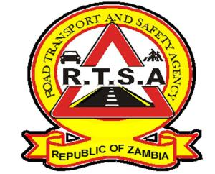

**ROAD TRANSPORT AND SAFETY AGENCY**

**PRESS STATEMENT**

**RTSA REMINDS UKUSEFYA PA NG’WENA TRAVELLERS TO BE EXTRA CAUTIOUS.**

**LUSAKA**, 18th August 2023 – The Road Transport and Safety Agency (RTSA) would like to remind all road users to adhere to all traffic rules and regulations ahead of the Ukusefya Pa Ng’wena traditional Ceremony this Saturday.

The Agency expects an increase in traffic volumes on the Great North Road and the Kasama – Mugwi Road in the run-up to the ceremony, which poses a high risk to road users if traffic rules and regulations are not followed.

The Agency has deployed Road Traffic Inspectors, who will be highly alert to ensure traffic rules and regulations are adhered to with special attention to speed and drunk driving, before, during and after the ceremony.

The RTSA would like to reiterate its call to members of the public to continue reporting bad, careless and dangerous drivers to the RTSA National Call Centre on the Toll-Free line- 983 and the WhatsApp line 0965-429499.

Issued and authorised for publication by:

Mukela Mangolwa

Acting Head – Public Relations

For Director/Chief Executive Officer

Road Safety House

Dedan Kimathi Road

**LUSAKA**