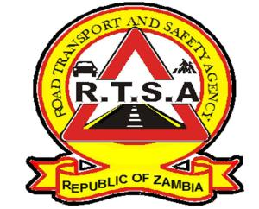

**ROAD TRANSPORT AND SAFETY AGENCY**

**PUBLIC NOTICE**

**DISRUPTION OF RTSA ONLINE SERVICES ON THE ZAMPORTAL**

**The Road Transport and Safety Agency (RTSA) would like to inform members of the public that the following online services are temporarily not available on the ZamPortal:**

1. **Examinations - Motor Vehicles and Trailers (physical inspection forms)**
2. **Driver Licence renewal**
3. **Motor Vehicle registration**
4. **Change of Motor Vehicle ownership**

**Members of the public are advised to visit any of the RTSA service centres to access RTSA services and will be informed as soon as the online services are restored.**

**The RTSA regrets the inconvenience this may cause.**

**For any queries contact the RTSA on 0211228793 or Email** [**askrtsa@rtsa.org.zm**](mailto:askrtsa@rtsa.org.zm) **or visit Facebook/askrtsa.com or website:** [**www.rtsa.org.zm**](http://www.rtsa.org.zm)

**Issued and authorised for publication by:**

**Ag. Head -Public Relations**

**For/Director and Chief Executive Officer**

**Road Transport and Safety Agency**

**Road Safety House**

**Dedan Kimathi Road**

**LUSAKA**