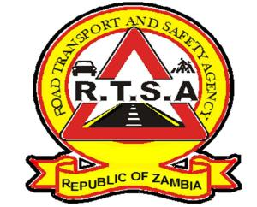

**ROAD TRANSPORT AND SAFETY AGENCY**

**PRESS STATEMENT**

**RTSA CALLS FOR SAFETY OF PUPILS AS SCHOOLS CLOSE**

**LUSAKA. 3rd August 2023.** – The Road Transport and Safety Agency (RTSA) would like to urge all road users to observe road safety rules and regulations as schools close on 4th August 2023 and in the wake of the Farmers Day holiday on 7th August 2023.

The Agency expects an increase in traffic on the roads during this period, posing a high risk to all road users if traffic rules and regulations are not followed.

All Motorists, especially Public Service Vehicle (PSV) drivers, are advised to be extra cautious and drive within the stipulated speed limits. The Agency is also calling on parents, guardians and school authorities to ensure their learners use appropriate and roadworthy modes of transport.

The Agency would also like to caution all road users to refrain from activities that may compromise road safety on the roads during the ongoing Zambia Agriculture and Commercial Show.

The RTSA and Zambia Police Service Traffic Section will be on high alert to ensure compliance with traffic rules and regulations among all road users.

The Agency reiterates its call to members of the public to report all bad, careless and dangerous drivers to the RTSA National Call Centre on the Toll-free line – 983 and the WhatsApp line 0965-429499.

**Issued and authorised for publication by**

**Acting Head-Public Relations**

**For/Director and Chief Executive Officer**

**Road Safety House**

**Dedan Kimathi Road**

**LUSAKA.**