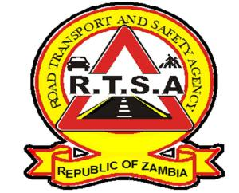

**ROAD TRANSPORT AND SAFETY AGENCY**

**PRESS STATEMENT**

**RTSA CALLS FOR SAFETY OF PUPILS AS SCHOOLS RE-OPEN**

**LUSAKA. 2nd September, 2023.** – The Road Transport and Safety Agency (RTSA) is urging all road users to observe road safety rules and regulations as schools open for the third term on Monday 4th September 2023.

The Agency expects an increase in traffic flow on the roads during this period which, poses a high risk to all road users if traffic rules and regulations are not obeyed.

Motorists, especially Public Service Vehicle (PSV) drivers, are advised to exercise utmost caution by driving within the stipulated speed limits while parents, guardians and school authorities are advised to make sure pupils use appropriate and road-worthy motor vehicles.

The RTSA, working with the Zambia Police Service Traffic Section will be on high alert to ensure motorists adhere to road traffic rules and regulations.

The Agency would like to remind members of the public to continue reporting all bad, careless and dangerous drivers to the RTSA National Call Centre on the Toll-free line – 983 and the WhatsApp line 0965-429499.

**Issued and authorised for publication by**

**Mukela Mangolwa**

**Acting Head-Public Relations**

**For/Director and Chief Executive Officer**

**Road Safety House**

**Dedan Kimathi Road**

**LUSAKA.**