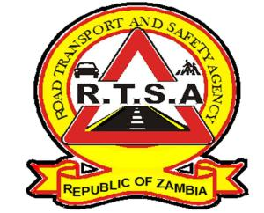

**ROAD TRANSPORT AND SAFETY AGENCY**

**PRESS STATEMENT**

**RTSA SADDENED BY DEATH OF 14 PEOPLE IN SERENJE ACCIDENT**

**….as the Agency nabs 80 for drink driving during Christmas period**

**LUSAKA, 27th December, 2023.** The Road Transport and Safety Agency (RTSA), is saddened by the death of 14 people in a road traffic crash that happened along the Great North Road. The road crash which happened in Serenje, Central Province on 26th December, 2023 involved a Tanzanian Truck and a south African registered Public Service Vehicle (PSV).

The RTSA Director and CEO is sending a message of condolences to the bereaved families and wishes the injured a quick recovery.

Meanwhile, the RTSA has nabbed 80 motorists countrywide for driving under the influence of alcohol and intoxicating liquor during an enforcement operation carried out during the Christmas period. This is in line with section 154 of the Road Traffic Act no. 11 of 2002.

All offenders nabbed for the vice will be prosecuted through the Courts of Law. The highest number of infringements were recorded in Luapula Province with 17 offenders, Copperbelt 16, Southern and Eastern provinces each recorded 11. The rest of the country recorded between 1 and 9 drink driving cases. The RTSA takes this opportunity to remind members of the public to always ensure they have a sober driver especially during this period.

The Agency also booked various motorists for various road traffic offences which included dangerous driving, expired Road Licence (road tax), expired certificate of fitness, alighting passengers, expired driver’s licence, expired insurance, expired test certificate and obstruction of roadway among other offences.

The RTSA has scaled up law enforcement operations targeting speed, non-use of seatbelts, use of mobile phones and drunk driving during the festive season. The Agency would like to reiterated its call on all road users to be extra cautions during the festive period and to be proactive and make use of the RTSA National Call Centre by reporting all bad, careless and dangerous drivers on the Toll-Free Line – 983 and the WhatsApp line 0965 429499.

Authourised for display and publication by:

27th December, 2023

**Mukela Mangolwa**

Acting Head – Public Relations

Road Transport and Safety Agency

Road Safety House

Dedan Kimathi Road

LUSAKA.