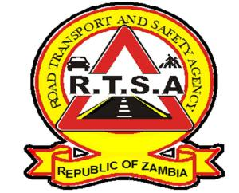

**ROAD TRANSPORT AND SAFETY AGENCY**

**PUBLIC NOTICE**

**PRINTING OF TEMPORARY DRIVING LICENCES (TDLs) ON SECURITY PAPER**

The Road Transport and Safety Agency (RTSA) would like to inform the General Public that the Agency (RTSA) has commenced printing of Temporary Driving Licences (TDLs) on the RTSA A4 security paper with immediate effect.

This is in line with the provisions contained in the Road Traffic (Driving Licence) Regulation No. 50 of 2020, which states that: “***Where the Agency is unable to issue a driving licence on demand, it shall issue the holder of a pass certificate a Temporary Driving Licence pending the issuance of a driving licence card”.***

This action will enable the Agency manage the migration to the approved Tripartite Transport and Transit Facilitation Program (TTTFP) SADC regional standard driving licence card which has been domesticated in Zambia.

To this effect, the RTSA and the Zambia Police Service shall immediately recognise the TDLs as legal documents that authorise any person to drive a motor vehicle of the description or class as stipulated therein until the new licence is in production.

**“Always observe speed limits- they are there for a purpose”**

For any queries contact the RTSA on 0211228798 or Email [**askrtsa@rtsa.org.zm**](mailto:askrtsa@rtsa.org.zm) **or visit Facebook/askrtsa.com or website:** [**www.rtsa.org.zm**](http://www.rtsa.org.zm)

Authorised for display and publication by: 22nd May 2024

**Ag. Head – Public Relations**

**For/ Director and Chief Executive Officer**

**Road Transport and Safety Agency**

**Road Safety House**

**Dedan Kimathi Road, LUSAKA**