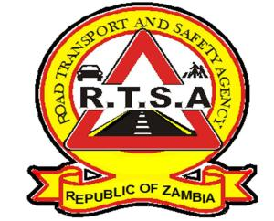

**ROAD TRANSPORT AND SAFETY AGENCY**

**PUBLIC NOTICE**

**CHARGING EXTRA FOR TEMPORARY DRIVING LICENCES (TDLs)**

The Road Transport and Safety Agency (RTSA) would like to inform the general public that the printing of Temporary Driving Licences (TDLs) on the RTSA A4 security paper is a temporal measure as the Agency migrates to the Tripartite Transport and Transit Facilitation Programme (TTTFP) compliant driving licence. The TTTFP is a regional transport facilitation programme established in 2002 by three (3) regional economic communities (RECs) in eastern and Southern Africa to facilitate the movement of goods, services and people across the region by simplifying and harmonizing transport regulations, reducing transit times and increasing trade efficiency.

This is in line with the provisions contained in the Road Traffic (Driving Licence) Regulations No. 50 of 2020, which states thus: “***where the Agency is unable to issue a driving licence on demand, it shall issue the holder of a pass certificate a Temporary Driving Licence pending the issuance of a driving licence card”.***

Further, members of the public shall not incur any extra cost after the initial payment for a driving licence has been made at the point of tendering a TDL either for extension or in exchange for a card at the time the TTTFP compliant driving licence cards will be available.

The RTSA enforcement team and the Zambia Police Service shall forthwith recognise the TDLs as legal documents that authorise any person to drive a motor vehicle of the description or class as stipulated there-in.

**Road Safety Tip; Always allow yourself to take short breaks when driving and stay safe.**

For any queries contact the RTSA on 0211228798 or Email [**askrtsa@rtsa.org.zm**](mailto:askrtsa@rtsa.org.zm) **or visit Facebook/askrtsa.com or website:** [**www.rtsa.org.zm**](http://www.rtsa.org.zm)

Authorised for display and publication by: Date:

**The Ag. Head – Public Relations**

**For/ Director and Chief Executive Officer**

**Road Transport and Safety Agency**

**Road Safety House**

**Dedan Kimathi Road**

**LUSAKA**