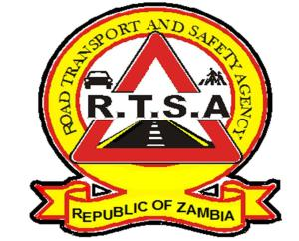

**ROAD TRANSPORT AND SAFETY AGENCY**

**PUBLIC NOTICE**

**ON-LINE BOOKING FOR THE PROVISIONAL DRIVING LICENCE THEORY TESTS ON THE GOVERNMENT SERVICE BUS**

The Road Transport and Safety Agency (RTSA) would like to inform the general public that booking for the Provisional Driving Licence for theory tests will be available on-line on the Zamportal.

The Agency has introduced this innovative solution in order to enhance service delivery and reduce congestion at the RTSA Stations.

The on-line booking service roll out will start with the RTSA Ridgeway and Mimosa stations with effect from 23rd July 2024 for both account holders and non-account holders on the Zamportal platform.

Please note that the RTSA Stations will no longer accept walk-in bookings from prospective clients.

For on-line bookings please go to [www.zamportal.gov.zm](http://www.zamportal.gov.zm) or www.rtsa.org.zm

**Road Safety Tip; Always Buckle Up for Safety.**

For any queries contact the RTSA on 0211228798 or Email [**askrtsa@rtsa.org.zm**](mailto:askrtsa@rtsa.org.zm) **or visit Facebook/askrtsa.com or website:** [**www.rtsa.org.zm**](http://www.rtsa.org.zm)

Authorised for display and publication by:

**Ag. Head – Public Relations**

**For/ Director and Chief Executive Officer**

**Road Transport and Safety Agency**

**Road Safety House**

**Dedan Kimathi Road**

**LUSAKA**