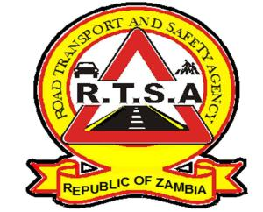

**ROAD TRANSPORT AND SAFETY AGENCY**

**PRESS STATEMENT**

**RTSA CAUTIONS KULAMBA AND LIKUMBI LYAMIZE GOERS**

**LUSAKA**, **23rd August, 2024**. The Road Transport and Safety Agency (RTSA) is urging all road users to observe road rules and regulations ahead of the Kulamba and Likumbi Lyamize Traditional Ceremonies of the Chewa and Luvale speaking people scheduled for this Saturday 24th August, 2024 in Katete and on Monday 26th August, 2024 in Zambezi District.

The Agency anticipates an increase in both vehicular and pedestrian traffic on the Great East and the Great North Roads leading to the host districts of the two ceremonies, which may pose a high risk to road users if traffic rules and regulations are not adhered to.

Motorists and riders are advised to exercise patience on the road, not to drink and drive, avoid overloading, fasten seat belts and to drive and ride within the stipulated speed limits.

Pedestrians are also reminded to be extra cautious and observe all road traffic rules during this period and avoid use of headsets while walking on the roads.

The RTSA and the Zambia Police will be on the ground to ensure adherence to traffic rules and regulations.

The Agency reiterates its call to members of the public to continue making use of the RTSA National Call Centre by reporting all bad, careless and dangerous drivers on the Toll-Free line – 983 and the WhatsApp line 0965-429499.

**Issued and authorised for publication by Date: 23rd August, 2024**

**Mukela Mangolwa**

**Acting Head-Public Relations**

**Road Safety House**

**Dedan Kimathi Road**

**LUSAKA.**