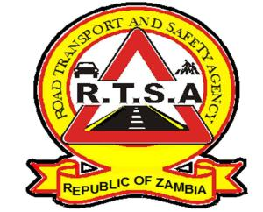 **ROAD TRANSPORT AND SAFETY AGENCY** **PUBLIC NOTICE**

**USE OF SEATBELTS AND CHILD RESTRAINTS**

The Road Transport and Safety Agency (RTSA), would like to inform and remind members of the public that failure to wear an obligatory seat belt and failure to secure a minor is an offence.

This is in reference to Section 167 and Section 168 of the Road Traffic Act no. 11 of 2002, and Statutory instrument (SI) no. 79 of 2016 respectively.

According to section 167 (2) (3) of the Road Traffic Act no. 11 of 2002, both drivers and passengers are required to wear seatbelts when the vehicle is in motion.

Members of the public are further reminded that SI No. 79 of 2016, section 4 (1) stipulates that a person carrying a child in a motor vehicle shall ensure that the child is strapped securely in a child seat while travelling in the motor vehicle, while section 4 (2) stipulates that a person carrying a child in a motor vehicle shall not put the child in the front passenger seat of the motor vehicle.

The law under section 168 of the Road Traffic Act further states that any Child under the age of 10 and less than one hundred and fifty centimetres in height should not occupy the front seat.

Failure to adhere to these regulations is an offence and may result in prosecution as specified by the Road Traffic Act.

The Agency will therefore continue to enforce the law in its totality.

Kindly take this as official notification.

For more information contact the RTSA on 0211228798 or Email [**askrtsa@rtsa.org.zm**](mailto:askrtsa@rtsa.org.zm) **or visit Facebook/askrtsa.com or website:** [**www.rtsa.org.zm**](http://www.rtsa.org.zm)

Authorised for display and publication by:

**Acting Head – Public Relations**

**For/ Director and Chief Executive Officer**

**Road Transport and Safety Agency**

**Road Safety House**

**Dedan Kimathi Road**

**LUSAKA**