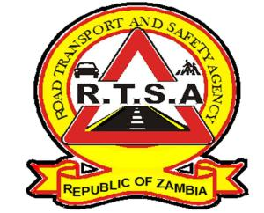

**ROAD TRANSPORT AND SAFETY AGENCY**

**PUBLIC NOTICE**

**ON-LINE BOOKING FOR THE PROVISIONAL DRIVING LICENCE THEORY TESTS**

The Road Transport and Safety Agency (RTSA) would like to inform members of the public that with effect from 23rd September, 2024, the Agency will no longer accept physical bookings for Provisional Driving Licence theory tests at the following Stations.

1. Ridgeway
2. Silverest
3. Cosmopolitan Mall
4. Kabwe
5. Ndola Industrial
6. Kitwe Main Station

Members of the public are further reminded that the online service is available on the Zamportal for the above mentioned stations.

For on-line bookings visit [www.zamportal.gov.zm](http://www.zamportal.gov.zm) or [www.rtsa.org.zm](http://www.rtsa.org.zm).

For more information contact the RTSA on 0211228798 or Email [**askrtsa@rtsa.org.zm**](mailto:askrtsa@rtsa.org.zm) **or visit Facebook/askrtsa.com or website:** [**www.rtsa.org.zm**](http://www.rtsa.org.zm)

Authorised for display and publication by:

**Ag. Head – Public Relations**

**For/ Director and Chief Executive Officer**

**Road Transport and Safety Agency**

**Road Safety House**

**Dedan Kimathi Road**

**LUSAKA**