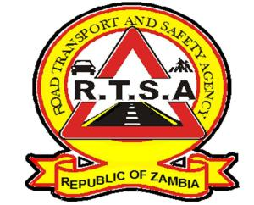

**ROAD TRANSPORT AND SAFETY AGENCY**

**PUBLIC NOTICE**

**INTRODUCTION OF THE ROAD TRAFFIC (DEMERIT POINT SYSTEM) STATUTORY INSTRUMENT**

The Road Transport and Safety Agency (RTSA) would like to inform all stakeholders and members of the public that the Government of the Republic of Zambia through the RTSA has introduced the Demerit Point System.

This follows the publication of the Road Traffic (Demerit Point System) Statutory Instrument No. 53 of 2024 in the Government Gazette on 30th August 2024 by the Minister of Transport and Logistics, Hon. Museba Frank Tayali pursuant to section 233 of the Road Traffic (Amendment) Act No. 8 of 2024.

The Road Traffic (Demerit Point System) Statutory Instrument No. 53 of 2024 is an SI that aims to promote road safety by encouraging responsible driving practices in the country and aligning Zambia to the requirements of the Multilateral Cross Border Road Transport Agreement (MCBRTA) under the Tripartite Transit Transport Facilitation Programme (TTTFP) that the country has migrated to.

The following are the key features of the Demerit Point System;

1. Allocation of Demerit Points for Traffic Offences.
2. Categories of Offences, Penalties and Corresponding Demerit Points.
3. Suspension or cancellation of a driver's license upon accumulating Demerit Points beyond the permitted maximum number.

Given the above, the RTSA will conduct sensitisations countrywide before implementing the SI.

Find attached a link to the list of the Offences, Penalties and Demerit Points.

**Road Safety Tip:** This rainy season and the festive season- Drive safely, reduce speed, maintain a safe following distance and do not drink and drive.

For any queries contact the RTSA on 0211228798 or Email [**askrtsa@rtsa.org.zm**](mailto:askrtsa@rtsa.org.zm) **or visit Facebook/askrtsa.com or website:** [**www.rtsa.org.zm**](http://www.rtsa.org.zm)

Authorised for display and publication by: 1st November, 2024

**Ag. Head – Public Relations**

**For/ Director and Chief Executive Officer**

**Road Transport and Safety Agency**

**Road Safety House**

**Dedan Kimathi Road**

**LUSAKA**